Category of Paper

Title of Paper [Calibri 22pt]
Sub-title [Calibri 17pt]
First Author ¹, Co-author ², Co-author ³ [Calibri 13pt Bold]
Institution, City, Country¹ ress Institution, City, Country ² Institution, City, Country ³ first.author@email.add[Calibri10pt Italic]
Title should be precise, informative and not too long. Please mention the name/s of author/s, completed with her/his/their affiliation using number/s in superscript as written above. Email address of the first author should be mentioned for correspondence purposes.

Abstract [Calibri 10pt Bold]
An abstract is a brief, comprehensive summary of the contents of the article; it allows readers to survey the contents of an article quickly and, like a title, it enables persons interested in the document to retrieve it from abstracting and indexing databases. Most scholarly journals require an abstract. Consult the instructions to authors or web page of the journal to which you plan to submit your article for any journal-specific instructions. A well-prepared abstract can be the most important single paragraph in an article. Most people have their first contact with an article by seeing just the abstract, usually in comparison with several other abstracts, as they are doing a literature search. Readers frequently decide on the basis of the abstract whether to read the entire article. The abstract needs to be dense with information. By embedding key words in your abstract, you enhance the user's ability to find it. Do not exceed the abstract word limit of the journal to which you are submitting your article. Word limits vary from journal to journal and typically range from 100 to 150 words. [Abstract text: Calibri 10pt]
Keywords: [Abstract text: Calibri 10pt] maximum 5 keywords.

- Introduction [ Heading Level 1: Calibri 10pt Bold]
Topic or theme of the paper should relevant with the mission of JISDeP and its audience covering sustainable development covering wide range of topic in the SDGs’ goals such as poverty, education health, gender, water and sanitation, energy, economic, infrastructure, communities, climate change, peas and justice and others. Good topic also can be identified whether it is something new the field and bringing about the innovation of the next research.
- Methodology
The research method should appropriate with the statement of the research problem. It should cover method used, measurement instrument, sampling method, data collection technique and data analysis. Data is described and adequate.
  - Analysis [Heading Level 2: Calibri 9pt Bold]
It is important to evaluate whether the analysis should address the research problem or not. Analysis should also address the implications and link to the research problem. The argument should also base on the strong theoretical framework, data and valid information.
- Results and Discussions
Results should be clear and concise. The results should summarize (scientific) findings rather than providing data in great detail. Please highlight differences between your results or findings and the previous publications by other researchers.

- Conclusions
Conclusions should answer the objectives of research. Tells how your work advances the field from the present state of knowledge. Without clear Conclusions, reviewers and readers will find it difficult to judge the work, and whether or not it merits publication in the journal. Do not repeat the Abstract, or just list experimental results. Provide a clear scientific justification for your work, and indicate possible applications and extensions. You should also suggest future experiments and/or point out those that are underway.

Acknowledgments
The Editorial Board would like to thank all the participants and other parties who have contributed in the journal.

The Length
The manuscript can be written in English language between approximately 15-20 pages.

Layout and Specification

Specification
Font type used is Arial throughout the paper, with font size as instructed in this template. Please use single spacing and align text to both the left and right margins.

Page Layout
Page size is A4 (210 mm x 297 mm) with 25 mm of top and bottom margins and 30 mm of left and right margins.

Article Layout
The easiest way to layout your article is by using this template directly.

Headings
Heading system should exactly follow this template.

Full Paper Submission
Please refer to the editorial board for submitting your full paper by online submissions.

Table
Presentation using tables can help explaining discussions more accurately and attractively. This way, presentation can also be shortened. Tables should be numbered continuously following the presentation order (Table 1, Table 2, and so forth). Table titles should be positioned as written below.

Table 1: Probabilities of Sky Conditions in Semarang for clear sky (ρcs), partly overcast sky (ρps), and fully overcast sky (ρos). [Table Title: Calibri 8pt]
Month | ρcs(%) | ρps(%) | ρos(%)
Jan | 24.38 | 1.23 | 57.24
Feb | 25.12 | 2.33 | 47.57
Mar | 36.21 | 1.79 | 54.12
Apr | 26.32 | 2.36 | 32.03
May | 31.22 | 2.54 | 43.55
Jun | 32.56 | 2.14 | 53.4
Source: Igawa and Nakamura, 2001: 765

Figures (Including Photos and Illustration)
Figures are allowed at maximum of 40% of the content and should be placed near the related or referred texts. All figures, photos and illustration should be numbered continuously according to the presentation order (Figure 1., Figure 2., and so forth).
Title of figure should be as complete as possible and should be positioned below the figure. All figures should be clear and readable, and no coloured figures are allowed. Please use fill patterns or line styles/markers to replace colour differences as exampled below.
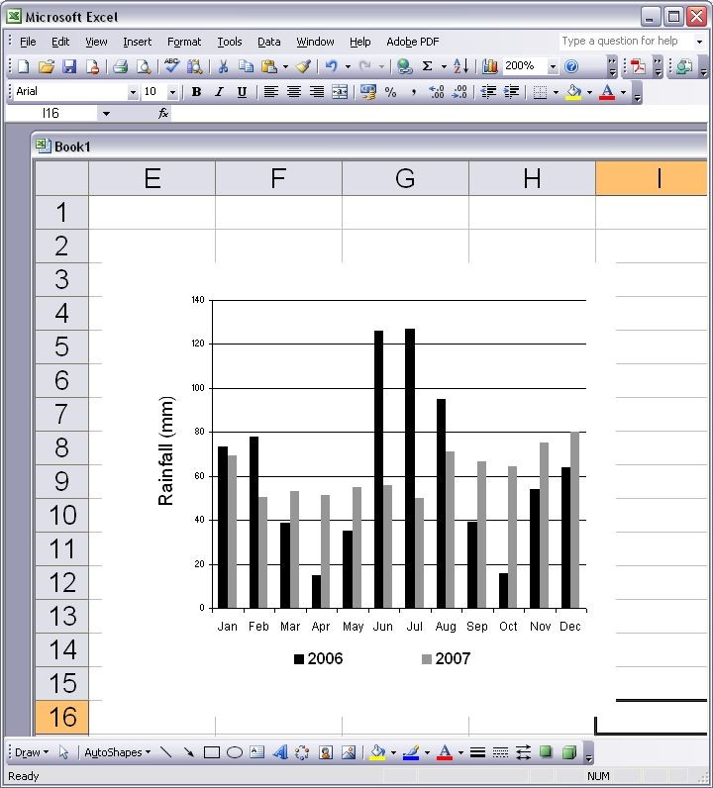
Figure 1. Monthly Rainfall in Semarang, 2006 and 2007 (International Daylight Monitoring Programme, 2008) [Title of Figure: Calibri 8pt]

Reference
- Cite the main scientific publications on which your work is based. Cite only items that you have read. Please refer to APA 7th Edition Format to write the references. Check each reference against the original source (authors name, volume, issue, year). Please use Reference Manager Applications like EndNote, Mendeley, etc. All publications cited in the text should be included as a list of references. Please ensure that every reference cited in the text is also present in the reference list (and vice versa).

- The reference/bibliography minimal 25 items from a journal or conference proceeding. Exclude Report, Thesis, Book, or website.

- Example of References (Apa 7th format):
Anderson, R., Dillon, J. L., & Hardaker, J. B. (1988). Agricultural Decision Analysis (3rd ed.). Armidale, Australia: University of New England.
Asuransi Jasa Indonesia (Jasindo). (2017). Agricultural Insurance Customer Data. Jasindo. Unpublished.
Binswanger, H. P., & Rosenzweig, M. R. (2007). Behavioural and material determinants of production relations in agriculture. The Journal of Development Studies, 22(3), 503–539. https://doi.org/10.1080/00220388608421994
Feder, G. (1980). Farm size, risk aversion, and the adoption of new technology under uncertainty. Oxford Economic Papers, 32(2), 263–283. https://doi.org/10.1093/oxfordjournals.oep.a041479
Gasson, R. (1973). Goals and values of farmers. Journal of Agricultural Economics, 24(3), 521–542. DOI: 10.1111/j.1477-9552.1973.tb00952.x
Zimmerman, F. J., & Carter, M. R. (2003). Asset smoothing, consumption smoothing, and the reproduction of inequality under risk and subsistence constraints. Journal of Development Economics, 71, 233–260. https://doi.org/doi.org/10.1016/S0304-3878(03)00028-2

