Research Paper

Title of Paper [Calibri 22pt]
Sub-title [Calibri 17pt]
First Author ¹, Co-author ², Co-author ³ [Calibri 13pt Bold]
Institution, City, Country¹ Adress Institution, City, Country ² Institution, City, Country ³ first.author@email.add[Calibri10pt Italic]
The title should be precise, informative, and not too long. Please mention the name/s of author/s, completed with her/his/their affiliation using number/s in superscript as written above. The email address of the first author should be mentioned for correspondence purposes.

Abstract [Calibri 10pt Bold]
Concisely describe the content and scope of your paper and identify the objective(s), its methodology, and its findings, conclusions, or intended results. Do not exceed the abstract word limit of the journal to which you are submitting your article. Word limits vary from journal to journal and typically range from 100 to 150 words. [Abstract text: Calibri 10pt]
Keywords: [Abstract text: Calibri 10pt] maximum 5 keywords.

- Introduction [ Heading Level 1: Calibri 10pt Bold]
State the objectives of your work and provide an adequate background, avoiding a detailed literature survey or a summary of the results. Explicitly state the gap in the literature, which signifies the significance of your research.
When paraphrasing a source that is not your own, be sure to represent the author’s information or opinions accurately and in your own words. Even when paraphrasing an author’s work, you still must provide a citation to that work. When directly quoting an author’s work, provide citation marks at the beginning till the end of the citation, and page number is necessary to be noted beside the name of the author and year of publication.

Literature Review:

Include the current knowledge including substantive findings, as well as theoretical and methodological contributions to your topic. A literature review surveys books, scholarly articles, and any other sources relevant to a particular issue, area of research, or theory, and by so doing, provides a description, summary, and critical evaluation of these works in relation to the research problem being investigated.

- Methodology
The research method should appropriate with the statement of the research problem. It should cover the method used, measurement instrument, sampling method, data collection technique, and data analysis. Data is described and adequate.
  - Analysis [Heading Level 2: Calibri 9pt Bold]
It is important to evaluate whether the analysis should address the research problem or not. Analysis should also address the implications and link to the research problem. The argument should also base on a strong theoretical framework, data, and valid information.
- Results and Discussions
Result: present the results of your work. Use graphs and tables if appropriate, but also summarize your main findings in the text. Do NOT discuss the results or speculate as to why something happened; that goes in the Discussion
Discussions: highlight the most significant results, but do not repeat what has been written in the Results section. The purpose of the discussion is to interpret and describe the significance of your findings in light of what was already known about the research problem being investigated and to explain any new understanding or insights that emerged as a result of your study of the problem. A combined Results and Discussion section is often appropriate.

Conclusions
Conclusions should answer the objectives of the research. Tells how your work advances the field from the present state of knowledge. Without clear Conclusions, reviewers and readers will find it difficult to judge the work, and whether or not it merits publication in the journal. Do not repeat the Abstract, or just list experimental results. Provide a clear scientific justification for your work, and indicate possible applications and extensions. You should also suggest future experiments and/or point out those that are underway.

Acknowledgments
Give credit to funding bodies and departments that have been of help during the project, for instance by supporting it financially.
The Length
The Research Paper can be written in the English language between approximately 20―25 pages.

Layout and Specification

Specification
The font type used is Calibri throughout the paper, with font size as instructed in this template. Please use single spacing and align text to both the left and right margins.

Page Layout
Page size is A4 (210 mm x 297 mm) with 25 mm of top and bottom margins and 30 mm of left and right margins.

Article Layout
The easiest way to lay out your article is by using this template directly.

Headings
The heading system should exactly follow this template.

Full Paper Submission
Please refer to the editorial board for submitting your full paper by online submissions.

Table
Presentation using tables can help explaining discussions more accurately and attractively. This way, the presentation can also be shortened. Tables should be numbered continuously following the presentation order (Table 1, Table 2, and so forth). Table titles should be positioned as written below.

Table 1: Probabilities of Sky Conditions in Semarang for clear sky (ρcs), partly overcast sky (ρps), and fully overcast sky (ρos). [Table Title: Calibri 8pt]
Month | ρcs(%) | ρps(%) | ρos(%)
Jan | 24.38 | 1.23 | 57.24
Feb | 25.12 | 2.33 | 47.57
Mar | 36.21 | 1.79 | 54.12
Apr | 26.32 | 2.36 | 32.03
May | 31.22 | 2.54 | 43.55
Jun | 32.56 | 2.14 | 53.4
Source: Igawa and Nakamura, 2001: 765

Figures (Including Photos and Illustration)
Figures are allowed a maximum of 40% of the content and should be placed near the related or referred texts. All figures, photos, and illustrations should be numbered continuously according to the presentation order (Figure 1., Figure 2., and so forth).
The title of the figure should be as complete as possible and should be positioned below the figure. All figures should be clear and readable, and no colored figures are allowed. Please use fill patterns or line styles/markers to replace color differences as exampled below.
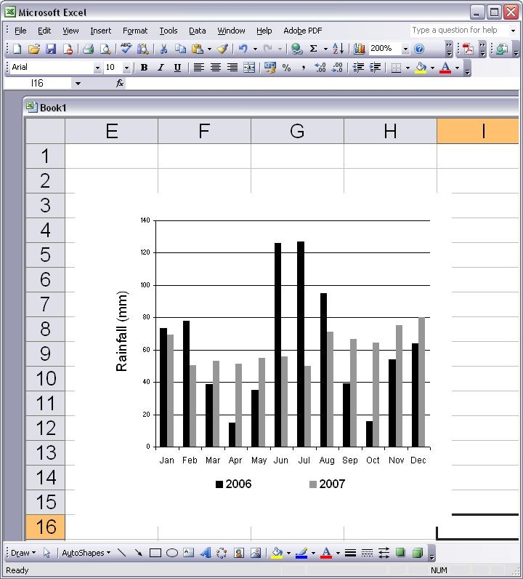

Figure 1. Monthly Rainfall in Semarang, 2006 and 2007 (International Daylight Monitoring Programme, 2008) [Title of Figure: Calibri 8pt]

Reference
- Cite the main scientific publications on which your work is based. Cite only items that you have read. Please refer to APA 7th Edition Format to write the references. Check each reference against the source (author's name, volume, issue, year). Please use Reference Manager Applications like EndNote, Mendeley, etc. All publications cited in the text should be included as a list of references. Please ensure that every reference cited in the text is also present in the reference list (and vice versa).

- The reference/bibliography minimal 25 items from a journal or conference proceeding. Exclude Report, Thesis, Book, or website.

