**Commentary**

Title of Paper [Calibri 22pt]

Sub-title [Calibri 17pt]

**Author [Calibri 13pt Bold]**

*1Institution, City, Country* **[Calibri 9pt Bold]**

[*author@email.add[Calibri*](mailto:author@email.add[Calibri) *8pt Italic]*

The title should be precise, informative, and not too long. Please mention the name/s of author/s, completed with her/his/their affiliation using number/s in superscript as written above. The email address of the first author should be mentioned for correspondence purposes.

|  |
| --- |
|  |

1. Introduction [ Heading Level 1: Calibri 10pt Bold]

The goal of publishing commentaries is to advance the research field by providing a forum for varying perspectives on a certain topic under consideration in the journal sustainable development planning in Indonesia. The author of a commentary probably has in-depth knowledge of the topic and is eager to present a new and/or unique viewpoint on existing problems, fundamental concepts, or prevalent notions, or wants to discuss the implications of a newly implemented innovation. A commentary may also draw attention to current advances and speculate on future directions of a certain topic and may include original data as well as state a personal opinion. While a commentary may be critical of an article published in the journal, it is important to maintain a respectful tone that is critical of ideas or conclusions but not of authors. The step to writing a commentary are:

1. Do not summarize the focal article; just give the reference. Assume the reader has just read it. Move directly to identifying the key issues you want to raise.
2. Do not include general praise for the focal article.
3. Use only essential citations. For commentary purposes, cite only works essential to support your point.
4. Use a short title that emphasizes your key message. (It should be clear in context that all commentaries are a reaction to a particular paper).
5. Do not include an abstract.
6. Make clear your take-home message.

Conclusions

Conclusions should answer the objectives of the research. Tells how your work advances the field from the present state of knowledge. Without clear Conclusions, reviewers and readers will find it difficult to judge the work, and whether or not it merits publication in the journal. Do not repeat the Abstract, or just list experimental results. Provide a clear scientific justification for your work, and indicate possible applications and extensions. You should also suggest future experiments and/or point out those that are underway.

The Length

The commentary in the journal of Indonesia Sustainable Development Planning (JISDeP) should be 4― 5 pages.

Layout and Specification

## Specification

The font type used is Calibri throughout the paper, with font size as instructed in this template. Please use single spacing and align text to both the left and right margins.

## Page Layout

Page size is A4 (210 mm x 297 mm) with 25 mm of top and bottom margins and 30 mm of left and right margins.

## Article Layout

The easiest way to lay out your article is by using this template directly.

## Headings

The heading system should exactly follow this template.

## Full Paper Submission

Please refer to the editorial board for submitting your full paper by online submissions.

Table

Presentation using tables can help explaining discussions more accurately and attractively. This way, the presentation can also be shortened. Tables should be numbered continuously following the presentation order (Table 1, Table 2, and so forth). Table titles should be positioned as written below.

**Table 1:** Probabilities of Sky Conditions in Semarang for clear sky (ρcs), partly overcast sky (ρps), and fully overcast sky (ρos). [Table Title: Calibri 8pt]

|  |  |  |  |
| --- | --- | --- | --- |
| **Month** | **ρcs(%)** | **ρps(%)** | **ρos(%)** |
| Jan | 24.38 | 1.23 | 57.24 |
| Feb | 25.12 | 2.33 | 47.57 |
| Mar | 36.21 | 1.79 | 54.12 |
| Apr | 26.32 | 2.36 | 32.03 |
| May | 31.22 | 2.54 | 43.55 |
| Jun | 32.56 | 2.14 | 53.4 |

Source: Igawa and Nakamura, 2001: 765

Figures (Including Photos and Illustration)

Figures are allowed a maximum of 40% of the content and should be placed near the related or referred texts. All figures, photos, and illustrations should be numbered continuously according to the presentation order (Figure 1., Figure 2., and so forth).

The title of the figure should be as complete as possible and should be positioned below the figure. All figures should be clear and readable, and no colored figures are allowed. Please use *fill patterns* or *line styles/markers* to replace color differences as exampled below.

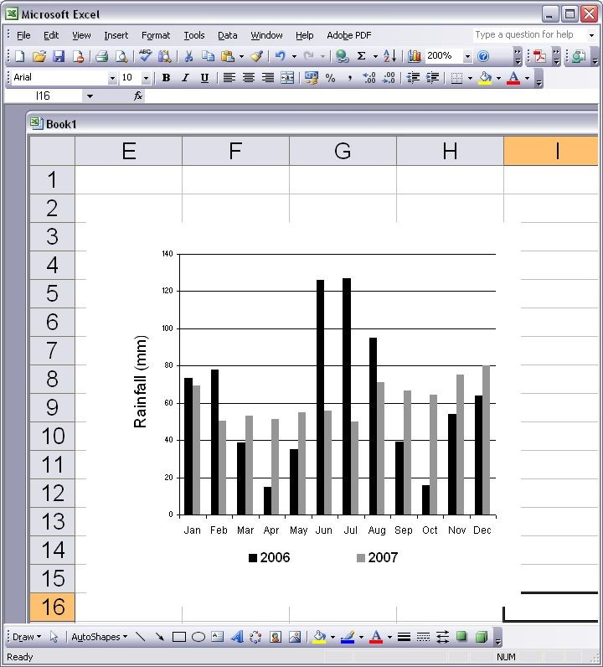

**Figure 1.** Monthly Rainfall in Semarang, 2006 and 2007 (International Daylight Monitoring Programme, 2008) [Title of Figure: Calibri 8pt]

Reference

Cite the main scientific publications on which your work is based. Cite only items that you have read. Please refer to [APA 7th Edition Format](http://ejournal2.undip.ac.id/index.php/ijpd/manager/setup/www.apastyle.org) to write the references. Check each reference against the source (author's name, volume, issue, year). Please use Reference Manager Applications like EndNote, Mendeley, etc. All publications cited in the text should be included as a list of references. Please ensure that every reference cited in the text is also present in the reference list (and vice versa).

The reference/bibliography minimal 25 items from a journal or conference proceeding. Exclude Report, Thesis, Book, or website.